In-Class Exercise - EM Algorithm
Yield Rate Estimation Lab Report | 2026
Coursework | Data Science Practice
Lab Objective | Practice EM Algorithm for machine yield-rate estimation
Datasets | test_case_1a.csv and real_world_data.csv
Deliverables | Completed code, result CSV files, and this report

1. Lab Summary
This lab estimates the yield rate of each machine step when some defect sources are latent. The completed workflow loads each dataset, one-hot encodes machine usage by lot, summarizes lot-level and machine-level statistics, initializes yield rates, then iterates the EM Algorithm until convergence or the maximum iteration count is reached.
Dataset | Output File | Rows | Iterations | Lowest Yield Machine
Simplified | test_report.csv | 7 | 30 | MS-14 (0.50574)
Real-world | realworld_report.csv | 216 | 38 | LS-061 (0.04805)

2. Modified Code and Execution Result
The missing main procedure was completed by calling the six required lab steps in order, then running both the simplified and real-world datasets.
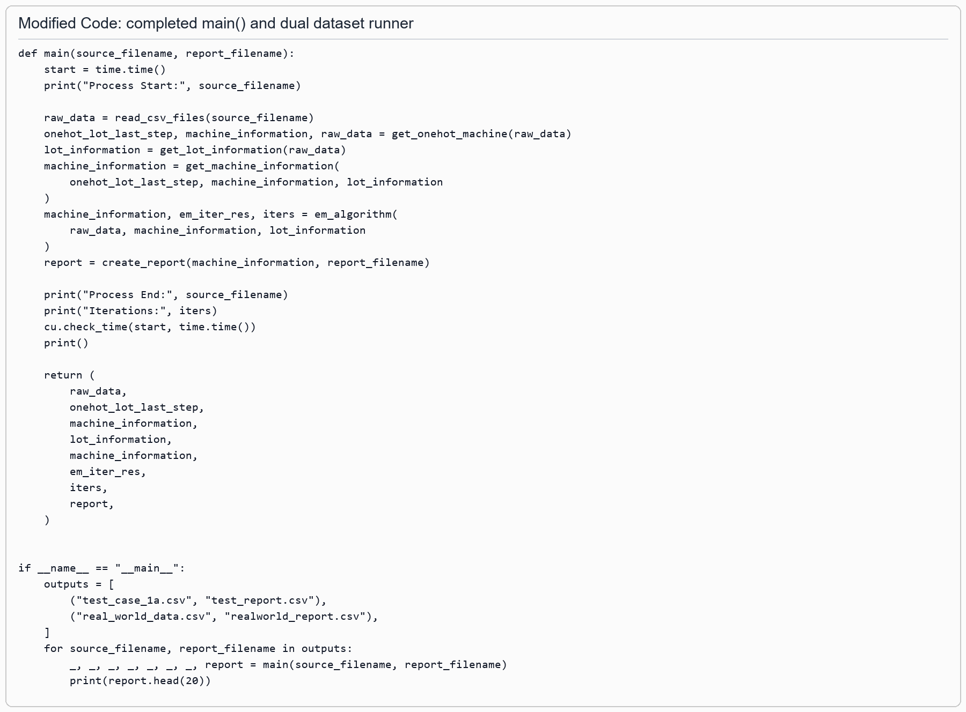
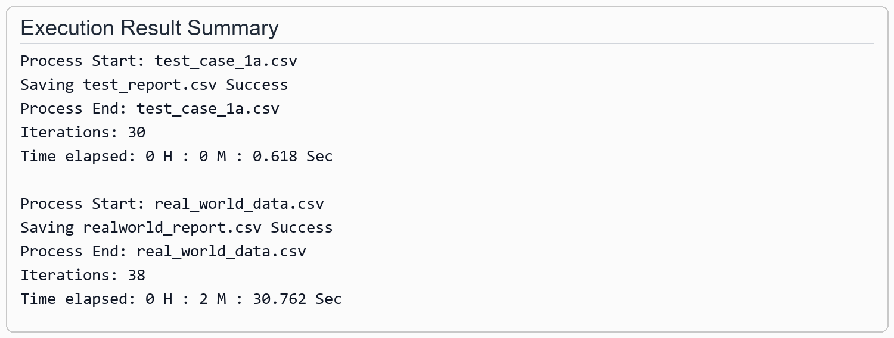

3. Result Screenshots and Tables
The reports are sorted by ascending yield rate, so the most suspicious low-yield machines appear at the top.
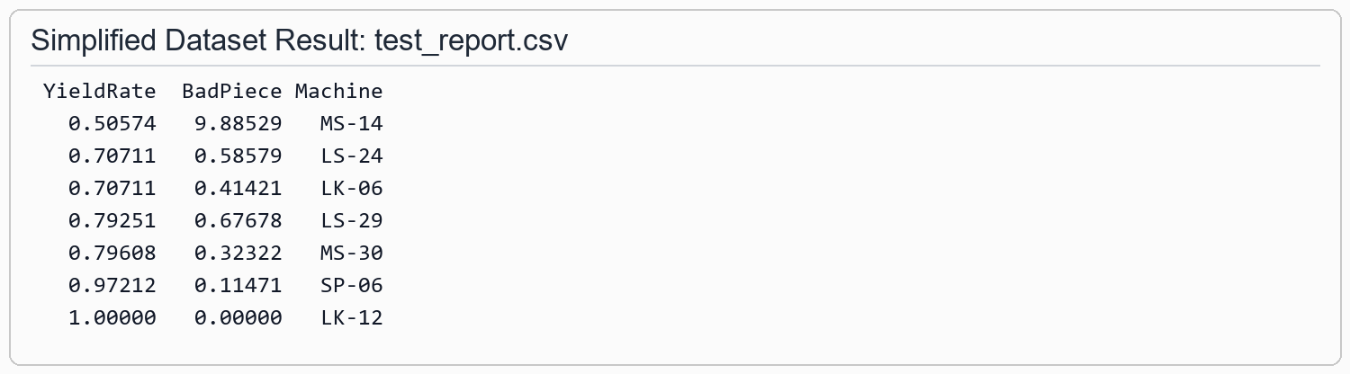

Top Machines - Simplified Dataset
YieldRate | BadPiece | Machine
0.50574 | 9.88529 | MS-14
0.70711 | 0.58579 | LS-24
0.70711 | 0.41421 | LK-06
0.79251 | 0.67678 | LS-29
0.79608 | 0.32322 | MS-30
0.97212 | 0.11471 | SP-06
1.00000 | 0.00000 | LK-12
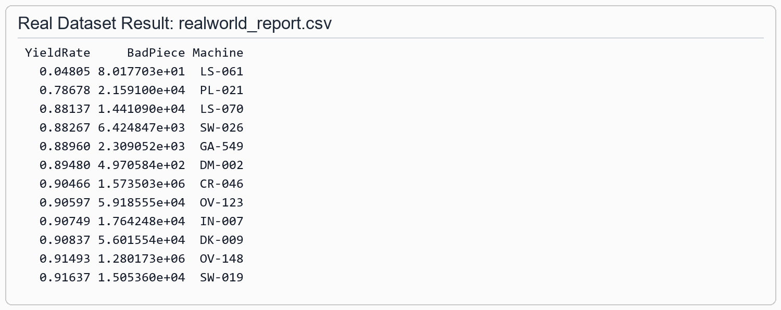

Top Machines - Real-World Dataset
YieldRate | BadPiece | Machine
0.04805 | 80.18 | LS-061
0.78678 | 21,591.00 | PL-021
0.88137 | 14,410.90 | LS-070
0.88267 | 6,424.85 | SW-026
0.88960 | 2,309.05 | GA-549
0.89480 | 497.06 | DM-002
0.90466 | 1,573,502.56 | CR-046
0.90597 | 59,185.55 | OV-123
0.90749 | 17,642.48 | IN-007
0.90837 | 56,015.54 | DK-009
0.91493 | 1,280,173.36 | OV-148
0.91637 | 15,053.60 | SW-019

4. Questions and Answers

Q1. Why do we use the EM algorithm to estimate machine yield rate?
The machine yield rates are not directly observable because a final defect can be caused by one of several machines used earlier in the process. EM is useful because it handles this hidden-cause problem: the E-step estimates how many observed bad pieces should be assigned to each possible machine, and the M-step updates each machine yield rate from those expected bad and good counts. Repeating the two steps gives a maximum-likelihood estimate even when the defect source is latent.

Q2. After the manufacturer has the machine yield-rate estimation results, what can they do?
The manufacturer can rank machines by estimated yield rate and expected bad pieces, identify the machines most likely to create defects, prioritize maintenance or calibration, schedule inspection for high-risk stations, and compare machines in the same process stage. The result supports targeted process improvement instead of stopping or checking every machine equally.

Q3. What did I learn from this lab?
I learned how an EM workflow converts incomplete manufacturing observations into usable machine-level estimates. I also learned how preprocessing matters: lot grouping, one-hot machine encoding, lot yield calculation, and careful handling of bad pieces all affect the final yield-rate ranking.

Q4. Any questions and/or difficulties in following the EM Algorithm topic?
The most difficult part is understanding the E-step allocation: one observed defect is distributed across several possible machines according to the current yield-rate estimates and the machines that came before it. Another practical difficulty is that the real dataset is much larger, so running the EM iterations takes noticeably longer than the simplified case.

5. Conclusion
For the simplified dataset, MS-14 has the lowest estimated yield rate. For the real-world dataset, LS-061 has the lowest estimated yield rate, followed by PL-021 and LS-070. These machines should be reviewed first because the EM results indicate they are the most likely contributors to observed defects.

